L1 – Student Loans – Reference Material

1. Education Financing in the US 4
2. Federal Regulations 4
2.1. Higher Education Act (1965) 4
3. Benefit Cycle 5
4. Key Players 6
5. Other players 8
6. National Student loan Data System (NSLDS) 8
7. Functional Participants 8
7.1. Eligible Lenders 8
7.2. Guarantee Agencies 10
7.3. Special Allowance and Interest Subsidy Payments 11
7.4. Eligible Servicers 11
7.5. Secondary Markets 12
8. Key concepts 12
9. Student Loan Processing Life Cycle 14
9.1. Application Processing 14
9.2. Loan Origination 15
9.3. Borrower Servicing 15
9.4. Default Management 16
9.5. Life Cycle of a Student loan 17
10. Loan Types 17
10. Loan Types 18
10.1. Federally sponsored loans 18
10.2. FFELP Loan Types 18
10.3. Federal Stafford Loans 18
10.4. Stafford Loans - types 18
10.5. Eligibilities for Federal Loans 19
10.6. PLUS Loans 19
10.7. Consolidation loans 19
10.8. Federal Direct loans 19
10.9. PERKINS LOANS 20
10.10. Difference between FDLP & FFELP Loans 21
10.11. Pell Grants 21
10.12. Federal Supplemental Educational Opportunity Grants (SEOG) 22
10.13. The Federal Work-Study (FWS) 22
10.14. Interest Rates on Federal Student Loans 22
10.15. Annual & Aggregate limits on borrowing 23
11. Repayment 23
11.1. Standard 23
11.2. Graduated 23
11.3. Income sensitive 23
11.4. Extended 24
11.5. Flex Repay 24
11.6. Select Step 24
11.7. Repayment terms for consolidation loans 24
11.8. Private Loan Repayment Plans 24
11.9. Deferment 25
11.10. Forbearance 25
11.11. Repayment incentives 25
11.12. Importance of Cohort Default Rates 25
12. Private Loans 26
12.1. Signature Student Loan 26
12.2. Interest rates for Signature Student Loan 26
12.3. Interest rates for MBA Loan 27
13. A Federal-State Partnership Program 28
14. Proportion of different loan types in Student loan industry 28
15. Student loan types - summary 29
16. Student Loan Industry Business Models 30
17. About Sallie Mae 30
17.1. Sallie Mae – An Introduction 30
17.2. History of Sallie Mae 31
17.3. Rationales for Privatization 32
17.4. Business Segments 32
17.5. Acquisitions 33
17.6. Financing 34
17.7. Students 34
17.8. Serving Schools 34
17.9. Support to Guarantors 34
18. Glossary of Terms 35

1. Education Financing in the US

According to the U.S. Department of Education (the Department), nearly 17 million students were enrolled at a higher education institution in 2003. This number has been increasing steadily for the last 20 years, and the Department estimates that 17.5 million students will be enrolled by 2010. In 2004, the federal government provided $81 billion to help students and families pay for a postsecondary education.

Federal student aid is offered to students who attend one of the more than 6,200 colleges, universities, and trade schools that participate in the federal student aid programs authorized by the Higher Education Act. A variety of federal programs help students and families finance an education.

- The total education spending worldwide is over $2 trillion and in the United States the spending is $750 billion
  - One-third ($250 billion) of this is on higher education
- More money is spent in on education than in any other industry with the exception of health care
  - Annual expenditures are more than Social Security and defense combined
- Less than 25%of the U.S.Adults have a B.A. or higher
- The US government plays a key role in ensuring education financing by acting as a guarantor or lender to all the loans issued by the government.

2. Federal Regulations

2.1. Higher Education Act (1965)

Objective:
In the year 1965, the Higher Education Act was enacted to create a nationwide federally guaranteed loan program based on the concept of private capital and decentralized guarantors.
To provide disadvantaged students with greater educational opportunities recognized the shared benefit of providing every American a chance to maximize his or her potential.
The Federal act has been amended periodically to suit to the business environment and plugging the loop hole s in the system to avoid misuse.

Features:
- Interest rates capped of 8.25%
- Origination fees chargeable by the lenders which is maximum 4% of the disbursal amount
- Limits to the amount students can borrow each academic year.
- Loan limits have been revised in 2005.

The Federal Family Education Loan Program(FFELP) and Federal Direct Loan Program (FDLP) are by far the largest of the programs coming under the purview of the act and also administered by Department Of Education(DOE)

3. Benefit Cycle
Government or Sponsor provides Guarantee and
Subsidy to Student Loan Program
(FFELP)
New Corporations create new
opportunities and incentive for
more students to achieve degrees
Skill-Enhanced
Workforce
Provides National
Economic Benefit
Educated workforce attracts
new corporations to countries
Educated students enter workforce,
earning higher salaries and performing
high-skilled professions
Based on the federal guarantees,
the private players issue student loans
Students receive loans to attend
University of choice and completes
educational goals

By guaranteeing student loans the government is able to build a benefit cycle that works as follows
- Government guarantees the student loans given by private players
- Using government support the private players issue loans to the students
- Students are thus able to attend universities of choice and complete their education
- After this they enter the workforce and work as high-skilled professionals in different areas
- This in turn attracts new corporations to countries
- These new corporations create new opportunities and incentive for for more students to achieve degrees
- This in turn results in more students taking loans and developing their education and the economy benefiting as a whole on account of the skilled workforce built this way

4. Key Players
Federal Government | Authorizes funds for grant and loan programs, such as the Federal Family Education Loan Program (FFELP)
School  (MIT,KELLOGS) | The school is certified by the Department of Education (DOE) as an eligible school to participate in the Federal Family Education Loan Program (FFELP) or the Federal District Loan Program (FDLP).  School determines borrower’s eligibility, recommends and certifies loan amounts, monitors the enrollment status.
Lender  (JPMC,Citi bank) | Approved by the DOE for voluntary participation in any or all of the FFELP student loan programs.  Banks, credit unions, S&L institutions, insurance companies and other institutions.
Servicer  (SallieMae,Nelnet) | Collects payments on a loan and performs other administrative tasks associated with maintaining a loan portfolio. Functions include disburse loans funds, monitor loans while the borrowers are in school, collect payments, process deferments and forbearances, respond to borrower inquiries and ensuring regulatory compliance.
Guaranty Agencies  (USAF) | Guarantees the loan and is a state sponsored or private not-for-profit agency. Protects the lender against loss due to borrower default, death of borrower, total and permanent disability, bankruptcy, closed school, and ineligible borrower.
Guarantor servicers | Contractors who provide data management and other support services for guaranty agencies on defaulted FFELP loans held by the guaranty agency.
Holder  (Sallie Mae) | Holders are the players who hold the student loan in their portfolio.This includes the loans originated by them and purchased from other lenders.
Collection Agency  (Client Services, Inc. ) | These agencies (often referred to as “PCAs” (“private collection agencies”)) come into action when a borrower defaults. They are responsible for tracking collection of monthly payments from the borrowers.
Secondary Markets | Most FFELP loans are sold by the originating lenders on the secondary market. Some 70% of outstanding FFELP loans are held by secondary markets. Sallie Mae holds about 40% of all outstanding FFELP loans; other secondary markets include major banks and “student loan authorities,” inc. CHELA. The latter typically hold beneficial ownership to the loans, while a trustee bank holds legal title. References in the HEA and FFELP regulations to “lender” include both originating lenders and secondary market purchasers.
Credit Bureaus | Credit Reporting Agencies usually refers to the three major credit reporting agencies; the HEA requires holders of HEA loans to report the status of each loan to at least one national reporting agencies.
Department of Education (DOE) | DOE reinsures guaranty agencies, pays lenders interest subsidies on need-based FFELP loans, and, when needed to assure “market yield” to the lender, an added interest subsidy (special allowance payments) on all FFELP loans.

The key players in the student loan industry are: Federal government, Schools, Lenders Servicers, guarantors, holders and the collection agencies. Federal government sponsors and authorizes funds for grants and loan programs. The school is certified by the department of education as an eligible school to participate in the Federal Family Education Loan Program or Federal District Loan Program loan programs.

Schools are responsible for determining borrower’s eligibility, recommends and certifies loan amounts, monitors the enrollment status. Lenders are the institutions approved by the DOE for voluntary participation in any or all of the FFELP student loan programs.
Typical lenders are usually Banks, credit unions, S&L institutions, insurance companies and other institutions.

A servicer is an entity who collects payments on a loan and performs other administrative tasks associated with maintaining a loan portfolio. The normal functions include disburse loans funds, monitor loans while the borrowers are in school, collect payments, process deferments and forbearances, respond to borrower inquiries and ensuring regulatory compliance.

A guarantor is a state agency, which guarantees or insures the loan and is a not-for-profit agency. It protects the lenders against loss due to borrower default, death of borrower, total and permanent disability, bankruptcy, closed school, and ineligible borrower.

The holders are the entities which hold the student loans in their balance sheets. They either originate these loans or purchase from other lenders from the secondary market who sell the loans to get capital for issuing fresh loans. Sallie Mae is the largest holder of the student loans.

The collection agency is an entity which comes into action when a borrower defaults. The agency is responsible for the tracking and collection from the borrower.

5. Other players
Some other players in the industry are:
- National Student Loan Clearinghouse
  - A student loan industry sponsored group
  - Nationwide database for student enrollment information.
  - Receives student data from various industry sources, compares the data, and reports and/or researches discrepancies
- US Dept of Health & Human Services
- National student loan data systems (NSLDS)

NSLCH maintains the data regarding the student enrollments for all the schools in US. It collects, maintains, researches on the data on the enrollment of students in various disciplines and schools. The data is accessible to all the players in the student loan industry.

6. National Student loan Data System (NSLDS)
- Dept of Education's central database for student aid
  - Receives data from schools, guaranty agencies, the Direct Loan program, the Pell Grant program, and other federal programs
  - Collects, organizes, and makes available detailed Title IV financial aid data on students, their loans, and Pell Grants
  - The data is collected and integrated from all organizations participating in the Title IV programs
From these default data the trends according to schools/states/courses are determined and this information is used in deciding loan program features.

7. Functional Participants

7.1. Eligible Lenders
FFELP loans are originated by eligible lenders, which are primarily commercial banks, credit unions, thrift institutions, insurance companies, state agencies and nonprofit student loan companies. Other originators can participate in the industry through the use of eligible lender trustees, which hold legal title to the loans on behalf of the lenders.

Historically, competition for origination volume (and secondary market purchase volume) focused on providing school financial aid officers and smaller lenders with value-added services. These services include items such as high-speed data processing links that streamline the application and disbursement process. Other services include specialized software packages that help financial aid offices manage their paper flow and loan servicing links, and forward sale agreements that help small lenders, such as community banks and credit unions, to originate and warehouse loan production. Today, lenders treat statutory program rates as maximum rates. They compete for volume by offering borrowers reduced origination fees, rebates of a portion of the lender margin, and flexible repayment terms. This marketing environment favors well-capitalized, high-volume lenders able to devote the fixed resources necessary to develop and support expensive value-added services and with the scale necessary to process volume profitably at reduced yields.

Top 10 Originators in 20041
Rank | Lender | Origination  Volume ( $Bn)
1 | Sallie Mae | $4.2
2 | Bank One Education Finance Group | 3.9
3 | Citibank Student Loan Corp | 3.4
4 | JP Morgan Chase Bank | 2.5
5 | Bank of America | 2.4
6 | Wells Fargo Education Financial Services | 2.3
7 | Wachovia Education Finance | 1.9
8 | US Bank | 1.1
9 | Access Group | 1.1
10 | EdAmerica | 0.9

Top 10 Holders in 2004
Rank | Lender | Holder Volume ($Bn)
1 | Sallie Mae | $85.10
2 | Citibank Student Loan Corporation | 21.55
3 | National Education Loan Network (NELNET) | 12.31
4 | Wachovia Education Finance | 10.07
5 | Wells Fargo Education Financial Services | 8.57
6 | Brazos Group | 7.53
7 | College Loan Corporation | 6.31
8 | Pennsylvania Higher Education Assistance Agency (PHEAA) | 5.45
9 | AELMAC/Southwest Student Services Corp | 4.71
10 | Goal Financial | 4.04

Top 10 Consolidators in 2004
Rank | Lender | Consolidation Volume ($Bn)
1 | Sallie Mae | $10.72
2 | National Education Loan Network (NELNET) | 2.97
3 | Citibank Student Loan Corporation | 2.73
4 | Collegiate Funding Services | 2.27
5 | College Loan Corporation | 1.97
6 | Brazos Group | 1.76
7 | Goal Financial | 1.69
8 | AELMAC/Southwest Student Services Corporation | 1.54
9 | Education Lending Group | 1.35
10 | Suntrust Bank | 0.75

7.2. Guarantee Agencies
The Higher Education Act requires each state to designate a single guarantor that must guaranty the FFELP loan of any student who is a state resident, or who is attending a school located in the state. The designated guarantor for most states is typically a state agency that administers a number of education finance-related programs for the state. Some states contract with guaranty agencies in neighboring states to serve as the designated guarantor for their state, or with a national guarantor such as USA Funds, Inc. (USAF). Guaranty agencies may guaranty loans from states where they are not the designated guarantor, and many of the larger guarantors compete for loan volume because of the value of lender relationships for related lines of business, such as third-party loan servicing and secondary-market activities.

To mitigate lender concerns about guarantor solvency, 1992 amendments to the Higher Education Act required the DOE to honor the guaranty obligations of insolvent guaranty agencies. Although the DOE has never drafted regulations that set out the conditions that would cause it to declare a guaranty agency insolvent, the major credit rating agencies believe that clear congressional intent makes it highly likely that the DOE will honor valid lender claims against an insolvent guaranty agency. Passage of the 1992 amendments was critical to the development of the student-loan ABS market because it allowed the rating agencies to assume that FFELP loans are guaranteed by a unit of the US Government, rather than by a number of thinly capitalized state guaranty agencies.

The DOE guarantees FFELP guarantors payment of 95% of principal and accrued interest due on defaulted loans. (Loans originated prior to July 1998 are guaranteed at 98% and loans prior to October 1, 1993, carry 100% coverage) Full reimbursement also applies to loans where the default was due to the death, disability, or bankruptcy of the borrower.

A loan is generally defined as defaulted when it becomes 270 days past due. Delays may occur from the time that the claim is made until the DOE reimburses the agency. Guaranty agencies fund claims payments to lenders primarily from reinsurance payments received from the DOE. Guaranty agencies generally receive 95% of claims expenses (loans originated prior to July 1998 are reinsured at 98%). However, if the agency has excessive default rates, (exceeding 5% of original principal) reinsurance rates can drop to as low as 75% of claims expense (see “Excessive Claims” in Appendix for details).

A number of guaranty agencies expanded their commitment volume in the late 1980s when FFELP regulations were changed, which resulted in increased lending to students attending proprietary trade schools. These loans defaulted at extremely high rates, and a number of guaranty agencies were merged into other guaranty agencies when they could not cover the shortfall between lender claims and DOE reinsurance payments.

7.3. Special Allowance and Interest Subsidy Payments
FFELP loans have borrower rates that generally adjust annually every July 1, subject to rate caps in a range between 8.25% and 11%. The DOE makes quarterly special allowance payments (SAP) to lenders when accrued interest on a loan over a calendar quarter at the uncapped lender yield exceeds accrued interest at the capped borrower rate. The DOE also makes quarterly interest subsidy payments to FFELP lenders equal to accrued interest on loans to borrowers eligible for federal interest subsidies while they are attending school. Lender yields on loans originated prior to January 1, 2000, generally equaled the 91-day Treasury bill rate, adjusted weekly, plus a margin. This margin ranges from 2.20% to 3.50%, depending on the loan type, disbursement date of the loan, and whether or not the borrower is attending school. Stafford loans originated after January 1, 2000, still have the interest reset adjusted every July 1st based on the last T-bill auction in May. However, the SAP paid on these Stafford loans is based on the daily average of the 3-month financial commercial paper (CP) rate for the previous quarter plus a margin ranging between 1.74% and 2.34%, dependent of the same characteristics mentioned above. Consolidation and PLUS loans originated after January 1, 2000, also receive SAP based on the above CP calculation, plus a margin of 2.64%. The commercial paper benchmark substantially reduces the lenders’ exposure to basis risk, and ultimately reduces this risk to investors.

7.4. Eligible Servicers
A guaranty agency can reject a guaranty claim submitted by a lender if the loan was not originated or serviced according to DOE guidelines. This means that lenders bear default risk on FFELP loans to the extent of uncured servicing errors, with loss severity ranging from the loss of accrued interest to full loss of principal and interest. Typical violations include due diligence errors made by originators, such as failure to verify a borrower’s eligibility for the program, and servicing errors such as the failure to contact a delinquent borrower within the required time limits.

FFELP reporting and processing guidelines are highly technical, and the penalty for violating a guideline is expensive. To minimize technical violations, the student loan servicing environment is highly automated, and many lenders contract out some or all of their underwriting, disbursement, and collections functions to high-volume, third-party servicers. Third-party servicers must meet solvency and performance standards to be eligible to service FFELP loans.

Top servicers
Rank | Servicers | Outstanding  ( $Bn)
1 | Sallie Mae | $87.90
2 | Nelnet | 18.9
3 | AES(PHEA) | 16.9
4 | ACS | 15.7
5 | Great lakes Education services | 15.6
6 | Citibank | 14.2
 | Others | 44.6

7.5. Secondary Markets
Many lenders hold subsidized loans only while the borrowers attend school and loan collections consist of quarterly federal interest subsidy and special allowance payments. These lenders typically sell loans to specialized investors called secondary markets when borrowers graduate and the loan servicing function shifts from quarterly collection of lump-sum federal payments to monthly collection of principal and interest from individual borrowers. Secondary markets include Sallie Mae, commercial banks, many of the state guaranty agencies, and a number of non-profit corporations. Secondary markets either keep the loans on their balance sheet, fund them through the issuance of student loan revenue bonds in the municipal bond market, or sell them into the ABS market. Not-for-profit entities tend to view their secondary market activities as revenue generating rather than member service function and attempt to earn a positive spread on their financing activities to subsidize other programs. Sallie Mae is the largest purchaser of secondary-market student loans in the market.

8. Key concepts
- Free Application for Federal Student Aid (FAFSA)
- This is the form used by the students to apply for financial need-based aid. As the name indicates the form is free of cost. In this form the student needs to write his/her income details and the courses in schools that he/she wants to pursue.
- Master Promissory Note (MPN)
- Promissory Note is the legal and binding contract signed between the lender and the borrower (student/parents) stating the rules and obligations of the borrower and the repayment conditions. Signing the MPN indicates that the borrower promises to repay the student loan(s). The note has important information about rights and responsibilities of the borrower.
- The borrower must sign a new MPN if he/she wants to change the lender.
- An MPN is good for 10 years from the date the borrower signs it. Borrower can use the MPN for any loan period that begins within the 10-year time frame, provided the borrower received the first loan disbursement within 12 months after he/she signed the note. Please refer the following link for detailed FAQ on the MPN. http://www.salliemae.com/apply/borrowing/mpn.html
- Student Aid Report (SAR)
- Informs the student of the Expected Family Contribution (EFC) and the financial aid for which the student is eligible.
- College financial aid offices use the report information to build a financial aid package for a student.
- Sent by the government 4 – 6 weeks after receiving a FAFSA. The SAR is sent up to six schools of the student’s choice.
- Disbursement
- The release of loan funds to the school for delivery to the borrower
- Co-payable to the student and the school.
- The money is first credited to the student's account for payment of tuition, fees, room and board and other school charges.
- Any excess funds are then paid to the student in cash or by check.
- Unless the loan amount is under $500, the disbursement will be made in at least two equal installments
- Delinquent
- When the borrower fails to make a payment on time, the borrower is considered delinquent.
Let’s say the payment date is on 1st business day of every month. If the student fails to make payment on that day, the borrower is considered delinquent.
- Default
- A loan is in default when the borrower fails to pay several regular installments on time (i.e., payments overdue by 270 days)
- If a student defaults on student loans then his credit history goes for a toss.
- Deferment
- Deferment means delaying of repayment. No payments are required on a student loan during the deferment period.
- For subsidized Stafford Loans, there is no interest that accrues during a deferment period. There are three types of deferments.
  - In-school Deferment – When a student is still enrolled in classes for at least half-time;
  - Unemployed Deferment – Applicable up to three years after leaving school; Needs to be applied for every year
  - Economic Hardship Deferment - If the earnings of the borrower below the limit for low standard of living as determined by the Bureau of Labor Statistics (BLS).
- For unsubsidized Stafford Loans, the interest is capitalized at the end of deferment period unless the borrower pays the accrued interest during the deferment period itself.
- Forbearance
- Forbearance is adjustments when the borrower is having financial difficulty. A borrower must explicitly apply for this.
- Forbearance usually runs for 6 to 12 months
- Forbearance provisions vary by loan type at lender’s discretion
- Key differences between deferment and forbearance
- Interest accrues and may be capitalized on all loans during forbearance, including loans that were formerly subsidized.
- Lender’s Request Assistance( LRA)
- Lender’s Request Assistance (LRA) is the letter that the lender sends to the guarantee agency (GA) after a student fails to repay the loans properly
- After getting this the GA tries to persuade the student to pay.
- Notice Of Default(NOD)
- If a student doesn’t repay even after the GA’s persuasion then the lender sends a Notice of default to the GA
- The guarantor gives the Guarantee money to the lender and informs the Department of Education and the NSLDS for necessary updates and action
- Cohort default rate
- A cohort default rate is the percentage of borrowers entering repayment on loans in a fiscal year and subsequently defaulting (or meeting other conditions) in that same fiscal year or the next fiscal year. This rate is important for tailoring different loan programs for different types of schools in different geographies.

9. Student Loan Processing Life Cycle
Typically a student loan processing life cycle comprises of

- Application processing
- Loan Origination
- Borrower Servicing
- Default management.

9.1. Application Processing
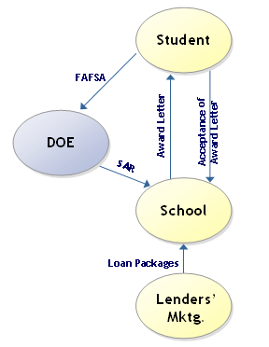
The typical loan process starts with the borrower applying for loans through filling up FAFSA. The Department of Education then creates a Student Aid Report (SAR). The SAR serves to indicate a student’s Expected Family Contribution (EFC). The school uses to calculate financial aid eligibility Schools send letter to the prospective students and families outlining the type and amount of financial aid for which they qualify. This may include combination of scholarships and grants. The preferred lender list is mentioned in the award letter from where the student can choose she wants to take loan. The schools have alliances with the lenders. Students commonly use the Financial AID package offered by the school to make their choice and they need to send the acceptance of the award letter to the school

9.2. Loan Origination
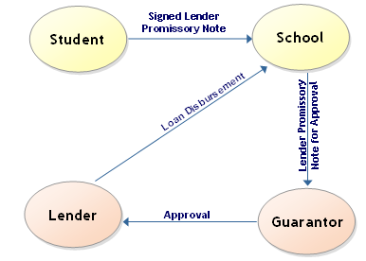
Students who decide to apply for an education loan must sign a lenders promissory note with the lender and send that to the school of choice. The school submits the Promissory Note to the guarantor for approval. The guarantor approves the loan, provides the federal guarantee and directs the Lender to proceed with the loan disbursement.
The Loan proceeds are disbursed by a lender or loan servicer and sent either to the school or to the borrower.

9.3. Borrower Servicing
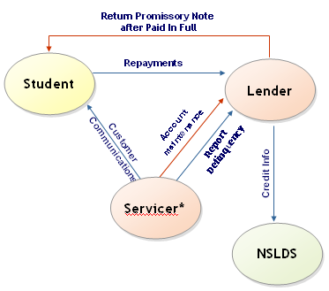
After a grace period of six months following the completion of studies the repayment starts. The servicer maintains the account of each borrower on behalf of the lender.
Loan servicers proactively contact borrowers who have fallen behind on loan payments to prevent them from defaulting. The servicer communicates to the borrower at different stages informing the necessary changes in the rules for payments, discounts offered if any. When the borrower pays the loan amount in full the loan closure happens and the lender returns back the Promissory note to the student and sends the payment history to the NSLDS. A lender can also act as a Servicer.

9.4. Default Management
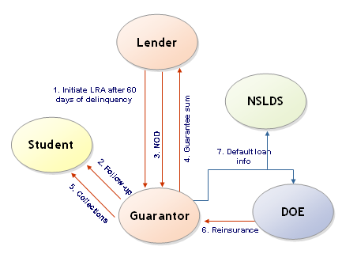
When the borrower becomes 60 days delinquent the lender sends a LRA (lenders request for assistance) to the guarantor and the guarantor pursues the borrower to repay. The Guarantor Performs due diligence according to federal regulations activities, including phone calls and letters which can be from Integrated auto-dialers or voice response systems. If the borrower is not repaying even after pursuance and the delinquency crosses 270 days the lender sends NOD to the guarantor. The Guarantor processes and verifies the Claims process and pays to the lender. Also makes necessary changes in the default portfolio. Guarantor sends the default loan information to the DOE asking for the reinsurance money. The default loan info is sent to NSLDS also for updating of the data base. In most instances, Guarantor uses a Servicer to perform these functions.

9.5. Life Cycle of a Student loan
1. College
Applications

College-bound students
must complete admissions
applications, secure
recommendations and prepare
personal essays

2. FAFSA

For some 1.3 million high school
students, the financial aid process begins with the Free Application for Federal Student Aid (FASFA). The U.S. ED uses the FAFSA to determine financial eligibility for grants, work-study
programs and student loans

3. Student Aid Report

Approximately two weeks after ED receives a student’s FAFSA, the agency creates a Student Aid Report (SAR). The SAR is returned to the student and sent to up to six schools of the student’s choice. The SAR serves to indicate a student’s EFC, which a college or university uses to calculate financial aid eligibility

4. Award Package

Once the SAR is complete, schools send a letter to prospective students and families outlining the type and amount of financial aid for which they qualify. This aid may include a combination of grants, work-study, scholarships and/or loans

5. School
Selection

When it comes to choosing a college or university, college bound students first evaluate and compare acceptance and award letters, including the entire financial aid award package that an institution has offered.
6. Federal Student
Loan Application

Students who decide to apply for an education loan to help pay for college must complete a lender’s application and sign a lender’s promissory note. Their school of choice then certifies that the student is enrolled and eligible for the loan and submits the application to the guarantor for approval
7. Federal Guarantee

A guarantor approves the loan, provides the federal guarantee and directs the lender to
proceed with loan disbursement
8. Federal Student Loan Origination

The loan proceeds are disbursed by the lender or loan servicer and sent either to the school or directly to the borrower

9. Private Loan Application

After maximizing their eligibility for federal student loans, students may apply for (complete the lender’s application form and sign the promissory note) private or alternative loans to cover any unmet need. Students must be approved for this credit-based loan, and some will seek a co-borrower in order to qualify. Once credit-approved, the lender makes the loan’s rates and fees available to the borrower and the co-borrower. The school certifies the loan and the lender or loan servicer prepares the loan for disbursement.

10. Private Loan Disbursement

The loan proceeds are disbursed by the lender or loan servicer and sent either to the school or directly to the borrower. A truth-in-lending disclosure statement is then sent to the borrower and the co-borrower. This statement gives the borrower the option of returning any of the loan funds (at any time).

11. In School

No payments on the loan principal are required if students remain in school at least half time. The government pays interest that accrues on Subsidized Stafford loans during this period. Students are responsible for interest that accrues while in school on Unsubsidized Stafford and private loans. Students have the choice of paying the interest while in school or capitalizing it and adding it to the outstanding principal balance of their loan.
12. Loan Repayment

Six months after a student borrower leaves school,
loan repayment begins. The lender or servicer sends
a repayment schedule to the borrower and any applicable co-borrowers approximately 45 days prior to the date when repayment begins. The lender collects monthly payments from borrowers and bills the government quarterly for special allowance payments (federal student loans only). Students may select from a variety of loan repayment options, including standard repayment, graduated repayment, extended repayment, income-sensitive repayment and loan consolidation

14. Loan Default

A federal student loan goes into default when it
is 270 days delinquent. Then, a guaranty agency
purchases the loan and files for partial reimbursement
from ED
15. Default Collection

Guaranty agencies work to locate and collect on defaulted federal
student loan accounts for the benefit of U.S. taxpayers.

16. Paid-In Full

Borrowers fulfill their repayment
obligations, and the principal and
interest balances on the loan are
reduced to zero.

13. Default Aversion

Loan servicers and guaranty agencies proactively contact borrowers who have fallen behind on loan payments to prevent the borrower from defaulting on the loan

10. Loan Types

Loans offered are of two types

- Federally sponsored loans – These student loans are federally insured and provide protection against default. The department of Education guarantees upto 98% or even 100% of principal insurance.
- Non-federally sponsored loans – These student loans are insured by the private sector and have no guarantee by DOE or government backing. The guarantee in this case is only from the private insurers or from the reserves pledged to securitization

10.1. Federally sponsored loans

Federally sponsored loans are of two types
- Federal Family Education Loan Program (FFELP)
In this type, the loans are made by financial institutions primarily with a floating rate that is adjusted once a year effective from July 1 to June 30. These loans are Authorized by the Higher Education Act of 1965 and are Federally insured student loans having protection against default The interest rate is capped at 8.25% and the Fed subsidizes the difference between the actual loan rate and the rate cap through Special Allowance Payments (SAP). The rates are usually specified by indexing them to the US Treasury bill rates. (For ex, it was 91 T-bill + 1.7% in school and + 2.3% during repayment)

- Federal Direct Loan Program (FDLP)
In this case the department of Education (DOE) directly provides the loans

10.2. FFELP Loan Types
- Subsidized Stafford Loans
- Unsubsidized Stafford Loans
- Federal PLUS (Parents loan for undergraduate students)
- Consolidation loans

10.3. Federal Stafford Loans
Federal Stafford loans are the most common source of education loan funds in the US. This is available to both graduate and undergraduate students. The interest rate is a floating rate that is indexed to the 91 day T-Bill and is capped at 8.25%
- 2003 - 2004 Rate
  - 2.82% in school, grace and deferment
  - 3.42% in repayment and forbearance

10.4. Stafford Loans - types
- Subsidized Stafford loans
- Given to the students who demonstrate sufficient financial need
- The federal government pays the interest on these loans during in-school as well as the grace period before repayment begins
- Unsubsidized
- Available for students who do not demonstrate sufficient financial need. The unsubsidized loans are not on need basis but on the unmet cost of schooling after getting the federal loan.
- The borrower is responsible for the interest on these loans as soon as the loan disbursement is made.
- The borrower is liable to pay the interest on loans while in school or in grace period. If the borrower decides not to pay the interest during the school days that the interest amount at the end of the period is added to original disbursed capital.

10.5. Eligibilities for Federal Loans
For a student to be eligible for Stafford loans, the following conditions need to be met
- The borrower should be a U.S. citizen or permanent resident
- Borrower must be full or half time undergraduate or graduate student
- A credit check is not required

10.6. PLUS Loans
- Parent Loan for Undergraduate Students (PLUS)
- Available to parents of a full- or half-time undergraduate student regardless of income or assets
- Requires no collateral
- Interest is tax deductible
- Cap on the interest rate at 9%; 2002 –03 rate was 4.86%
- PLUS Eligibility
- U.S. citizen or permanent resident
- Parent of full- or half-time undergraduate student
- Requires a credit check. Beginning July 1, 1993, parents were required to have a satisfactory

10.7. Consolidation loans
- A consolidation loan involves replacing two or more existing federally sponsored loans - Federal Stafford, PLUS with a new loan
- Interest rate is fixed, determined by the weighted average of loans, rounded up to nearest 1/8th percent, and capped at 8.25%
- This provided three principal advantages to the borrowers.
  - Convenience – By combining loans the borrower is able to focus on repaying one single loan than handle multiple loans
  - Interest rate – In a low rate scenario the borrower can reduce his cost of borrowing by taking a new loan at the low prevailing low rates
  - Repayment – The repayment period is extended to 30 years and this reduces the installment to paid each month
- This does NOT include Private loans!!!

10.8. Federal Direct loans
- Federal Direct Loan Program (FDLP)
- The federal direct loan program was introduced as an alternative to replace the FFELP program. The William D. Ford Federal Direct Loan Program (direct loans or FDLP) was established in 1993. It is administered by the U.S. Department of Education and was initially intended to replace the FFELP.
- DOE acts as the lender for FDLP. Since the government acts as the guarantor there is no reinsurer required.
- The loan options are the same as FFELP – Stafford, PLUS and consolidation. FDLP is offered through some selected schools and schools have to decide whether to go for FDLP or not.

10.9. PERKINS LOANS
Federal Perkins loans are low interest student loans awarded by colleges on the basis of need. College financial aid offices determine the qualifications and the loan limits.

The primary features of this loan program are:
- Eligibility: Borrower must be a U. S. citizen or permanent resident, full or part-time undergraduate or graduate student.
- Loan limits:
- Undergraduate: $4,000 per year to $20,000 maximum.
- Graduate: $6,000 per year to $40,000 maximum.
- Interest rate: Five percent (fixed for the life of the loan).
- Total origination or insurance fee: None.
- Repayment term: Up to 10 years.
- Minimum payment: $40 per month per loan.
- Interest subsidy: Student pays no interest while in school.
- Repayment begins: Nine months after leaving school.

10.10. Difference between FDLP & FFELP Loans
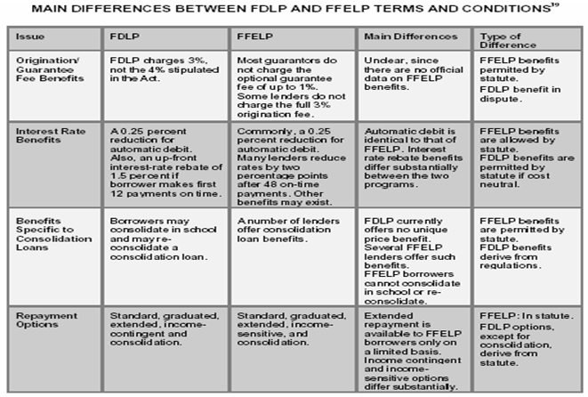

10.11. Pell Grants
The centerpiece of federal student aid is the Pell Grant program, named in honor of former Senator Claiborne Pell of Rhode Island, who championed its creation. These grants, which do not have to be repaid, are awarded to undergraduate students solely on the basis of financial need. Students may use a federal Pell Grant at any eligible institution. More than 5.3 million students receive these grants every year.

The federal Pell Grant is known as a quasi-entitlement because all eligible students receive assistance. The amount of a Pell Grant awarded to an individual student depends on the student’s EFC and attendance status (full time or part time), and the maximum grant as specified in the most recent federal appropriations process. In other words, all eligible students will receive a grant—the “entitlement” part—but the amount of a student’s grant will depend on the funding provided for the program as part of the annual appropriations process—the “quasi” part.
Because federal funding for the Pell Grant program is appropriated almost a full year before the start of the academic year, it is difficult to predict exactly how much money will be needed. For example, the fiscal 2004 appropriations bill— signed into law on January 23, 2004—provided funds for the 2004–05 school year. In some years, Congress provides more money than is needed and the Pell Grant program has a surplus. In other years especially when the economy stumbles and college enrollments grow, the program runs a shortfall.

When there is a surplus, the appropriations committees reallocate the unused funds in a future appropriations bill. Conversely, in the case of a deficit, the committees provide additional funding in a future appropriations bill to cover the shortfall. For academic year 2004–05, Congress appropriated $12 billion for this program, and individual awards ranged from $400 to $4,050, with the average approximately $2,469. The average family income for a dependent student receiving a Pell Grant was $24,600, while average family income for independent students was $15,500.

10.12. Federal Supplemental Educational Opportunity Grants (SEOG)
Support undergraduate students with “exceptional financial need” and usually go to students who also receive large Pell Grants. Recipients get between $100 and $4,000 a year, depending on need and availability. In 2004–05, 1.2 million students received an average SEOG of $765.

10.13. The Federal Work-Study (FWS)
FWS program provides jobs for undergraduate and graduate students with financial need, allowing them to earn money to pay educational expenses, often in areas related to their academic program or in community service positions. Students are generally paid by the hour and must receive at least the federal minimum wage. Last year, nearly 1 million students earned an average award of $1,450 through the FWS program. Currently, at least 7 percent of FWS funds must be spent on placing students in community service positions.

10.14. Interest Rates on Federal Student Loans
Thanks to federal subsidies, federal student loans are made to any eligible borrower at below market interest rates. As a result, federal student loans are the best option available in the consumer marketplace for education borrowers. Interest rates on FFEL student loans are set by the statute as follows:
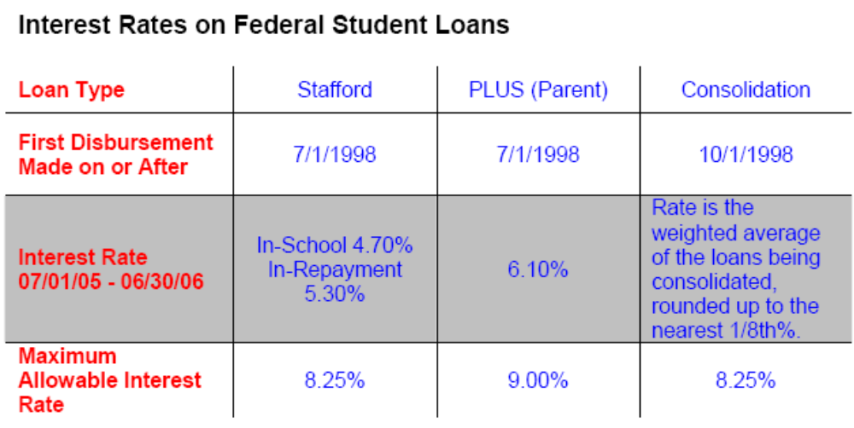
The lowest interest rates apply to Stafford Loans issued since July 1, 1998. The rate on these variable rate loans resets each July 1st based upon 91-day Treasury bill rates. In 2005-2006, the interest rate on these loans in repayment is 5.3 percent. Students still in school who are accruing interest on their loans pay a lower 4.7 percent rate. For parents’ PLUS Loans issued since July 1, 1998, the rate during 2005-2006 is 6.1 percent. The rates in place today are the fourth-lowest in the 40-year history of the student loan program.

10.15. Annual & Aggregate limits on borrowing
Stafford (Subsidized and Unsubsidized combined): annual limit for dependent undergraduate borrowers: $2625 / $3500 / $5500 for first year/ second year/ third and remaining undergraduate;

Stafford (Unsubsidized in addition to subsidized): annual limit for independent undergraduate borrowers: $4000 each for first year & second year; $5000 each remaining undergraduate year; annual limit for graduate and professional: $10,000/year

Aggregate: $46,000 undergraduate, $138,500 graduate or professional

PLUS: cost of attendance for student less other financial aid

11. Repayment
After education is complete and the six months grace period is over the repayment starts on a monthly basis In common parlance this is called EMI (Equated monthly payments).
The borrower pays back to the lender or the holder of the loans. There are different repayment options available for Federal loans
- Standard Repayment (level payment plan)
- Graduated Repayment
- Income-Sensitive / Income contingent Repayment
- Extended Repayment
- Flex Repay
- MAX 2/4
- Select Step

11.1. Standard
The standard payment option is generally used unless the payer has some other plans. The payment lasts for 120 months. In this option the borrower has to pay the least total interest amount.

11.2. Graduated
The graduated payment option as the name suggests calls for lesser payments during beginning and increases subsequently, with 10 year repayment period. Here the borrower can pay the interests only for four years and not any capital. The ultimate total interest cost is higher in this option.

11.3. Income sensitive
In the income sensitive option the payments that one needs to make is related to the income, which can vary time to time. Monthly payments increase or decrease based on the income of the borrower. The payment is usually between 4% to 25% of the gross monthly income and the borrower must provide the proof of income annually. Every year the borrower has to apply for the changes that he intends to make in the payment amount. The payments can go up to 15 years from the normal time period of 10 years. The borrower will be paying higher total interest in the long run.

11.4. Extended
The extended option is available if the total debt is at least $30000. The monthly payments are lower which spans across 25 years opposed to the usual 10 years. Though the option entails lower EMIs, the total interest amount paid by the borrower is higher.

11.5. Flex Repay
Flex Repay, a Sallie Mae exclusive, gives additional payment relief and eligibility for money-saving benefits to qualified borrowers.

With Flex Repay, eligible Federal Stafford and PLUS loan borrowers can make low payments in the early years of repayment. Then, if the borrowers continue to need payment relief, they may qualify for gradual step-ups in the payment amounts, depending on loan balances. Standard payments will follow for the remainder of the repayment terms.

If the balances on Sallie Mae-owned and -serviced education loans are under $20,000, the borrower may qualify for up to 13 years to repay. If the balances total $20,000 or more, the borrower may qualify to repay for up to 15 years. Partial or full prepayment is allowed at any time without penalty.

11.6. Select Step
Select Step allows the borrowers to make interest only payments in the early years of repayment with a later increase to standard payments of principal and interest.

11.7. Repayment terms for consolidation loans
Depending on the amount of your outstanding student loan balance, you have up to 30 years to re p a y, and you have a choice of the same repayment options offered for Federal Stafford Loans. There is no prepayment penalty, deferment and forbearance are available, and some lenders offer payment incentives.

11.8. Private Loan Repayment Plans
Most private student loan providers do offer both Standard (Level) Repayment Plans and Graduated Repayment Plans. (The Income-Sensitive Repayment Plan, the Extended Repayment Plan, and Federal Loan Consolidation are only available for FFELP loans.)Access Group offers the EasyPay 2 Step and the EasyPay3 Step Graduated Repayment Plans described above on its private loans. It also offers Payment Incentives on both its federal and private loans.

11.9. Deferment
Deferment is a period of time during which you can postpone your loan payments on Federal Stafford Loans or Federal Consolidation Loans. Deferments are an entitlement that your federal loan lender/holder/ servicer must approve if you meet the requirements and provide the necessary documentation as specified in the promissory note. For example, you might qualify for a deferment if you are enrolled in an eligible graduate fellowship program or if you face unemployment or other economic hardships.

11.10. Forbearance
Forbearance is an agreement between the borrower and the lender/holder/servicer of a loan that allows for:

- Temporary postponement of payments;
- Extension of time for making payments; or
- Temporary acceptance of payments that are smaller than re q u i red by the repayment schedule.

Forbearances are available at the discretion of the lender for both federal and private loans.

11.11. Repayment incentives
Some loan providers offer interest rate discounts to borrowers who demonstrate excellent repayment habits. You may be eligible for such benefits by making a certain number of consecutive on-time payments or by having loan payments deducted from your checking account.

11.12. Importance of Cohort Default Rates
Cohort Default rate (Percentage) is defined as the ratio of the following

- Numerator – The number of borrowers entering repayment in the cohort fiscal year as defined above and who defaulted before the calculation date.
- Denominator – The number of borrowers who entered repayment in the cohort fiscal year as defined above.

Sanctions for Schools with High Official Cohort Default Rates
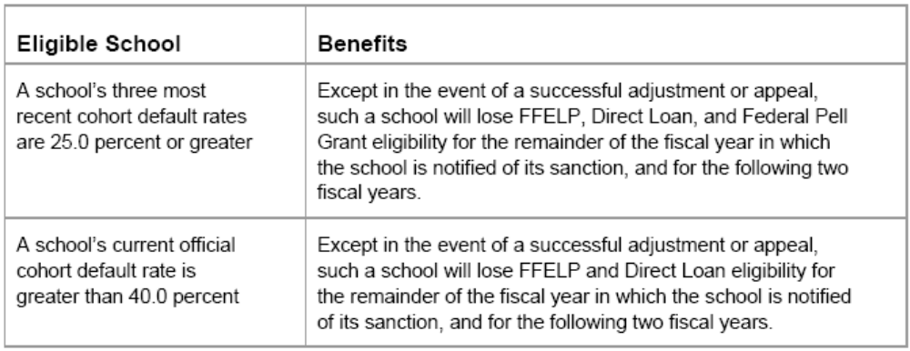

12. Private Loans
- These are private loans from a variety of sources that are designed for students and their parents. The following are the main sources:
- Financial institutions
- Educational institutions
- Professional associations
- Private loans are often used to supplement federal loans and other aid to cover the full cost of education
- Special programs may be available for graduate students in business, law and medical professions
- Helps students who exhaust their FFELP borrowing capacity
- Enrolled in expensive private institutions or lengthy graduate or professional degree programs and need additional loans
- The borrowers need not pay the interests during the studies and 6 months grace period.
- Repayment Options similar to Federal Stafford Loans
- Unable to be consolidated with federal loans – but can be “combine-billed”
- Has a variable interest rate that is not capped and they vary loan-to-loan, bank-to-bank and student-to-student.

12.1. Signature Student Loan
- Signature student loan is the most popular private loan after Stafford loans, which helps the borrowers to cover the total cost of the education.
- This loan is available for undergraduate, graduate, or graduate health profession students.
- This loan has a cosigner option. The borrowers can apply with a cosigner if they do not have an established credit history. Even if the borrower has an established credit history, he/she may be eligible for a lower interest rate if the borrower applies with a cosigner.

12.2. Interest rates for Signature Student Loan

Interest rate interim | Interest rate repayment | Disbursement fee | Repayment fee | APR | Monthly payment
Prime – 0.25% | Prime –  0.25% | 0% | 0% | 6.22% | $110.00
Prime + 0.50% | Prime + 0.50% | 0% | 0% | 6.90% | $118.00
Prime + 1% | Prime +  1% | 0% | 0% | 7.35% | $124.00
Prime + 1.75% | Prime +  1.75% | 0% | 0% | 8.02% | $133.00
Prime + 2.5% | Prime +  2.5% | 3% | 3% | 9.28% | $150.00
Prime + 6% | Prime +  6% | 0% | 3% | 12.01% | $196.00

Assumptions: Constant Prime Rate of 6.75%; $10,000 loan taken out freshman year, one disbursement of $5,000 on September 1 and a second disbursement of $5,000 on January 2. Fifty-one months pass (45 months in school plus 6 months grace) before 180-month repayment term begins. Monthly payment amount rounded to the nearest dollar.

12.3. Interest rates for MBA Loan

Interest rate interim | Interest rate repayment | Disbursement fee | Repayment fee | APR | Monthly payment
Prime – 0.75% | Prime – 0.75% | 0% | 0% | 5.92% | $95.00
Prime + 0% | Prime +  0% | 0% | 0% | 6.65% | $101.00
Prime + 0.50% | Prime +  0.50% | 0% | 0% | 7.13% | $105.00
Prime + 0.25% | Prime +  0.25% | 0% | 3% | 7.24% | $106.00
Prime + 1% | Prime +  1% | 0% | 0% | 7.61% | $109.00
Prime + 1.25% | Prime +  1.25% | 0% | 3% | 8.22% | $115.00
Prime + 3.50% | Prime +  3.50% | 0% | 0% | 10.00% | $132.00

Assumptions: Constant Prime Rate of 6.75%; $10,000 loan taken out the first year of graduate school, one disbursement of $5,000 on September 1 and a second disbursement of $5,000 on January 2. Twenty-seven months pass (21 months in school plus 6 months grace) before 180-month repayment term begins. Monthly payment amount rounded to the nearest dollar.

Please refer the link http://www.salliemae.com/apply/borrowing/interest.html for more details on interest rates of the various private loan types.

13. A Federal-State Partnership Program
The Leveraging Educational Assistance Partnerships (LEAP) program is designed to encourage states to maintain and expand need-based grant programs. States must match federal funds on a dollar-for-dollar basis. However, when the federal appropriation for LEAP reaches $30 million, the state match increases to $2 for every federal dollar. States that provide the higher match gain additional flexibility in spending the money—they can use it for increased grant aid, merit scholarships for needy students, and scholarships in specialized academic areas.

It is difficult to determine how many students benefit from LEAP because some states provide far more money—and therefore more scholarships—than is required to match the federal contribution. Last year, more than 1 million college students received a need-based state grant.

14. Proportion of different loan types in Student loan industry
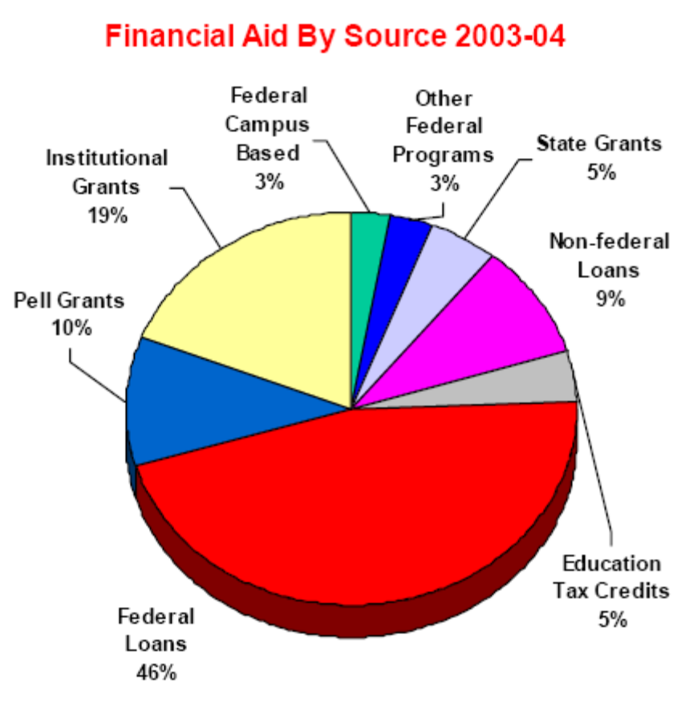
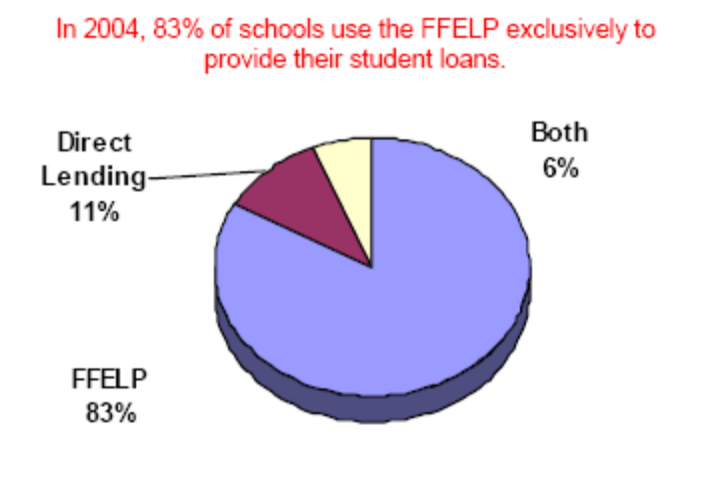

15. Student loan types - summary
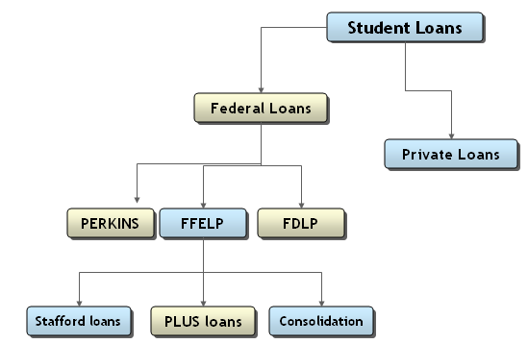

Differences between Student Loans & other loans
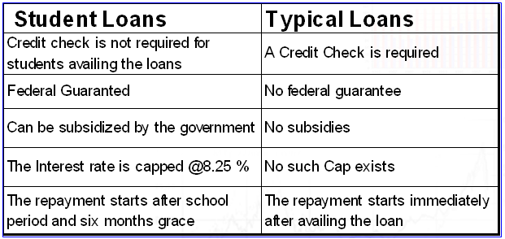

16. Student Loan Industry Business Models
- Fully Vertically Integrated: Originates and purchases, holds loans, rarely sells, provides servicing and origination functions for self and others
- Partially Vertically Integrated: Originates and purchases, holds loans, rarely sells, requires third party servicing and/or origination functions
- Traditional Banking Model: Originates and sells loans, does not want to be vertically integrated
- Pure Secondary Market: Purchases, does not originate, holds loans, may require third party servicing
- Loan Consolidators: New entrant, direct to consumer marketing experts, originates and holds/sells loans, may require third party servicing and origination functions

Sallie Mae is one of the very few fully vertically integrated companies in the US Student loan industry.

17. About Sallie Mae

17.1. Sallie Mae – An Introduction
SLM Corporation, more commonly known as Sallie Mae, is the market leader in education finance. SLM Corporation is a holding company that operates through a number of subsidiaries and is the largest private source of funding, delivery and servicing support for education loans in the United States primarily through their participation in the FFELP. The company now ranks 6th among diversified financial companies, according to Business Week magazine.

Sallie Mae’s 10,000 employees across the country service student loans for more than 7 million borrowers. The company recorded revenues of $5.2 Billion during the fiscal year ended December 2004, an increase of 25.8% over 2003.The net income was $1.9 Billion during fiscal year 2004, an increase of 24.8% over 2003.Founded in 1973 as a government-sponsored enterprise (GSE), Sallie Mae was originally chartered as a secondary market, purchasing student loans. In 1997, Sallie Mae obtained permission to dissolve its GSE charter, enabling it to perform a broader range of activities related to higher education. Since then, the company has developed a presence in every step of the student loan life cycle—from helping families plan and pay for education to collecting on defaulted student loans.

Sallie Mae has received the following honors and rankings

- Named one of the Fortune Top Performing Stocks (Fortune magazine)
- One of the 100 Best Corporate Citizens (Business Ethics magazine)
- One of the Top 30 Companies for Executive Women (National Association of Female Executives)
- One of Business Week’s Top Corporate Philanthropists and One of the 15 Top Cash Givers (Business Week Magazine)
- Member of InformationWeek’s 500 most innovative users of information technology in the U.S.

Sallie Mae 1997 | Sallie Mae Today
Government Sponsored Enterprise | Fully Privatized
Wholesale Buyer of Student Loans | Retail provider of education credit and related services
Financed in US agency bond market | Financed in private capital markets
Preferred channel originations totaled approximately $ 4.7bn | Preferred channel originations of $18bn in 2004
Managed Student loans of $ 43.7 bn | Managed Student loan portfolio of $ 121 bn as on Sep 2005

17.2. History of Sallie Mae
Sallie Mae was formed in 1972 to improve the flow of funds into student lending. By creating a financial intermediary with access to the capital markets, initially through the government and later through its agency status, Congress sought to provide a source of liquidity to student loan lenders, who could sell their loans to Sallie Mae or obtain funding at capital market rates using an otherwise illiquid asset as collateral. The ability to sell student loans also allowed lenders to be active in the market without incurring the high costs of servicing. Sallie Mae's mission from the outset was to attract private capital for the financing of higher education.

By the mid-1990s, Sallie Mae was widely judged to be successful in achieving its mission. The guaranteed student loan program attained widespread acceptance among students, lenders and schools. Student lending volumes soared, funding became reliable, and active competition among a variety of institutions emerged in the market. Despite attempts to curb eligibility through needs testing in the early 1980s, annual lending volume was maintained at levels between 3 and 6 times that of the 1970s throughout the decade. The number of lenders participating in the program increased from approximately 4,000 in the early 1970s to more than 11,000 in the mid-1980s. The environment in which Sallie Mae operated changed dramatically since its creation. The integration of domestic and global capital markets expanded funding options for lenders and the application of computer technology to information and transaction processing greatly improved the origination and servicing options for lenders. By 1992, the major lenders in the student loan market included both money center and super regional banks. Collectively, the top 25 originators accounted for 45 percent of originations in 1992.

More importantly, the government profoundly changed the student loan market in the 1990s. The Omnibus Budget Reconciliation Act of 1993 (“the Act”) initiated a process to replace the Federal Family Education Loan Program (“the FFELP”) with direct lending by the federal government, funded through Treasury borrowing rather than private capital. In addition, the law mandated interest rates instead of allowing the rates to be set by market forces. These changes effected Sallie Mae’s revenues. On the expense side the Act imposed a 30 basis point per annum offset fee on loans held or guaranteed that effectively eliminated Sallie Mae’s funding advantage. Finally, Sallie Mae was mandated to act as a lender of last resort for students who could not get guaranteed loans because of high default rates at their education institutions.

In the backdrop of these changes, Sallie Mae’s management decided it could not stand pat. Competition was increasing, both from major lenders and the federal government and Sallie Mae’s major GSE advantage, access to relatively cheap funding was seriously eroded. In addition, Sallie Mae faced rising operating costs due to federally imposed mandates. As early as 1993, Sallie Mae began investigating alternatives to GSE status – most importantly privatization.

17.3. Rationales for Privatization
Three rationales emerged for the privatization of Sallie Mae.
- First, the public policy purpose for which it was created had been achieved;
- Second, investors faced a significant threat to the value of their investment from the political uncertainty surrounding the GSL program;
- Third, there were significant foregone opportunities associated with Sallie Mae's restrictive charter.

The Student Loan Marketing Association (Sallie Mae) was privatized through an Act of Congress in 1996.4 Sallie Mae re-organized under a holding company charter with a GSE and non-GSE subsidiaries. The GSE activities were limited and terminated on December 29, 2004 almost 4 years ahead of schedule.

17.4. Business Segments
SLM provides a comprehensive array of credit products and related services to the higher education community through two primary business segments:

- Lending business segment
- Debt Management Operations business segment

Within the Corporate and Other business segment, SLM also provides a number of complementary products and services to financial aid offices and schools that are managed within smaller operating segments, the most prominent being the

- Guarantor Servicing
- Loan Servicing businesses

SLM generates the largest share of earnings in their Lending business from the spread between the yield that they receive on their Managed portfolio of student loans, and the cost of funding these loans.

In DMO business, SLM earns fee revenue for portfolio management, debt collection and default prevention services on a contingent fee basis concentrated mainly in the education finance marketplace.

In Lending business segment, SLM originates and acquires both federally guaranteed student loans which are administered by ED, and Private Education Loans, which are not federally guaranteed. Private Education Loans are primarily used to supplement FFELP loans in meeting the cost of education.

SLM manage the largest portfolio of student loans in the industry, serving more than seven million borrowers through our ownership and management of $107.4 billion in Managed student loans, of which $96.0 billion or 89 percent are federally insured.

It serves a diverse range of clients that includes over 6,000 educational and financial institutions and state agencies. They are also the largest servicer of student loans, servicing more than eight million borrowers totaling $110.5 billion in student loans. In addition to education lending, they also originate mortgage and consumer loans with the intent of selling most of these loans. In 2004 it originated $1.5 billion in mortgage and consumer loans and the mortgage and consumer loan portfolio totaled $449 million at December 31, 2004, of which $167 million pertains to mortgages in the held for sale portfolio.

17.5. Acquisitions
An important component of SLM’s growth strategy has been strategic acquisitions. Beginning in 1999 with the purchase of Nellie Mae, it has acquired several companies in the student loan industry that has increased their sales and marketing capabilities, added significant new brands and greatly enhanced their product offerings.

Strategic student lending acquisitions have included Student Loan Funding Resources and USA Group, Inc. (“USA Group”) in 2000, and AMS in 2003. In 2004 SLM acquired two companies (1) Arizona-based, Southwest Student Services Corporation (“Southwest”) and (2) Student Loan Finance Association that included a controlling interest in the business of Washington Student Loan Finance Association and Idaho Student Loan Finance Association (collectively, “SLFA”). The SLFA acquisition is a two-step transaction that will be completed in 2005. In conjunction with the SLFA transaction, NELA, a non-profit regional guarantor, entered into an affiliation with USA Funds, the nation’s largest guarantor and Sallie Mae’s largest guarantor servicing client. NELA contracted for Sallie Mae to provide comprehensive operational and other guarantor services to NELA.

17.6. Financing
With the completion of the GSE Wind-Down, SLM now funds their operations exclusively through non-GSE sources, primarily through the issuance of SLM Corporation (“SLM”) student loan asset-backed securities (securitization) and SLM debt securities. They issue these securities in both the domestic and overseas capital markets using both public offerings and private placements.

17.7. Students
Sallie Mae offers federal education loans— primarily Federal Stafford Loans, Federal Parent Loans for Undergraduate Students (PLUS) and Federal Consolidation Loans—and low-cost private loans to students and parents. Sallie Mae’s customer-focused services allow borrowers to go through the entire process online, from application to account management and even selection of repayment options, all via www.salliemae.com. Eligible borrowers can also qualify for a 3.3 percent loan credit or refund check through Sallie Mae’s Cash Back® Program.

17.8. Serving Schools
Sallie Mae continues to set the standard with innovative products for schools. Internet-based services allow schools real-time query, update and reporting capabilities. Sallie Mae and its subsidiaries provide college-financing, debt-management, default-prevention, financial-management and tuition payment advisory services. The company also provides collection services, as well as enrollment and retention-management consulting services to higher education institutions.

17.9. Support to Guarantors
Sallie Mae serves guarantors by offering administrative and technical support and providing a centralized point of contact for operational, technical, contractual and policy issues.

18. Glossary of Terms

AAMC | Association of American Medical Colleges
ABA | American Bar Association
Academic year | A period schools use to measure a quantity of study
ACH | Automated Clearing House
Actual interest rate | The annual interest rate a lender charges on a loan
AGI | Adjusted gross income.
ALP | Alternative Loan Program
Amortization | The process of repaying a loan over an extended period through regular installments of principal and interest
APR | Annual percentage rate. The effective interest rate on a loan, including all fees and other charges
Anticipated completion date | The day a student is expected to complete an academic program
Award letter | An official document issued by a college financial aid office listing all the financial aid they can give the student
BLS | Bureau of Labor Statistics
Borrower | The person who receives the loan
CIS | U.S. Citizenship and Immigration Services
CP | Commercial paper
DOE, ED, USED, DE | Department Of Education
Default | Failure to repay a student loan according to the agreed-upon terms of a promissory note
Deferment | A period when a borrower, who meets certain criteria, may suspend loan payments
Delinquency | Failure to make monthly loan payments when due
Demographics | Information about the vital data (age, sex, address) for a borrower.
Disbursement | The release of loan funds to the school for delivery to the borrower.
EFA | Estimated financial assistance
EFC | Expected Family Contribution
EFT | Electronic funds transfer
FAA | Financial aid administrator
FAFSA | Free Application for Federal Student Aid
FAO | Financial Aid Office
FDLP | Federal Direct Loan Program
FFELP | Federal Family Education Loan Program
Financial aid | Monetary assistance in the form of scholarships, grants, work-study, and loans for education
Forbearance | Temporary delay or reduction of loan payments agreed to by the lender and borrower
FSAIC | Federal Student Aid Information Center
FSEOG | Federal Supplement Educational Opportunity Grant
FWS | The Federal Work-Study
GA | Guarantee Agency
Grant | A financial aid award that does not have to be repaid
GSE | Government-sponsored enterprise
Guarantee amount | The principal amount insured by the guarantor as listed on the Notice of Loan guarantee
Guarantee agency | A state or private non-profit agency that insures student loans for lenders and administer the student loan insurance program for the federal government
In-school | The period when borrowers are enrolled at least half time
HEA | Higher Education Act
HEAL | Health Education Assistance Loan
Late fee | A fee that may be assessed if a scheduled payment is not made by the due date
LEAP | The Leveraging Educational Assistance Partnerships
Lender | A financial institution that provides funds to the borrower
LRA | Lender’s Request Assistance
MEDLOANS | A private or alternative loan program for medical students sponsored by AAMC
MPN | Master Promissory Note
NELA | Northwest Education Loan Association
NELNET | National Education Loan Network
NOD | Notice Of Default
NOLG | Notice of Loan guarantee
NSLDS | National Student loan data system
PCA | Private Collection Agencies
PHEAA | Pennsylvania Higher Education Assistance Agency
PIN | Personal identification number
PLUS | Parents loan for undergraduate students
SAP | Special allowance payments
SAR | Student Aid Report
Secondary market | An organization, like Sallie Mae, that purchases loans from lenders, thus providing the lender with more money to make loans available to other students who need to borrow money
SEOG | Federal Supplemental Educational Opportunity Grants
Servicer | An organization that administers and collects loan payments
SLFA | Student Loan Finance Association
SLMA | Student Loan Marketing Association
Stafford Loans | Loans, both subsidized (need-based) and unsubsidized (non-need-based), guaranteed by the federal government
Subsidized loan | A loan eligible for interest benefits paid by the federal government
Title IV | A section of the Higher Education Act of 1965, as amended, that authorizes federal loan, work, and grant education financial assistance programs
Unsubsidized loan | A non-need-based loan where the borrower is responsible for paying the interest on loan during in-school, grace, and deferment periods
USAF | USA Funds

